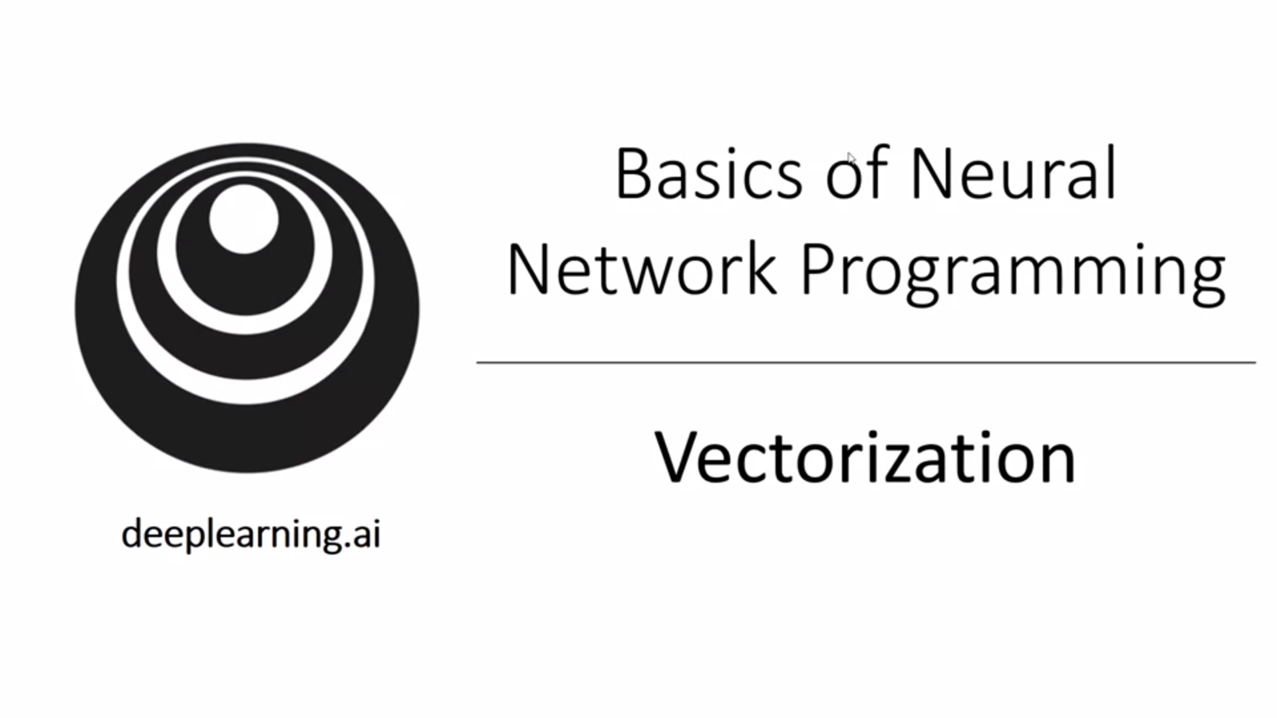

Vectorization: the art of getting rid of explicit for loops in your code.

In deep learning we have very large datasets so it is important that the code runs quickly. Vectorization is a key skill!

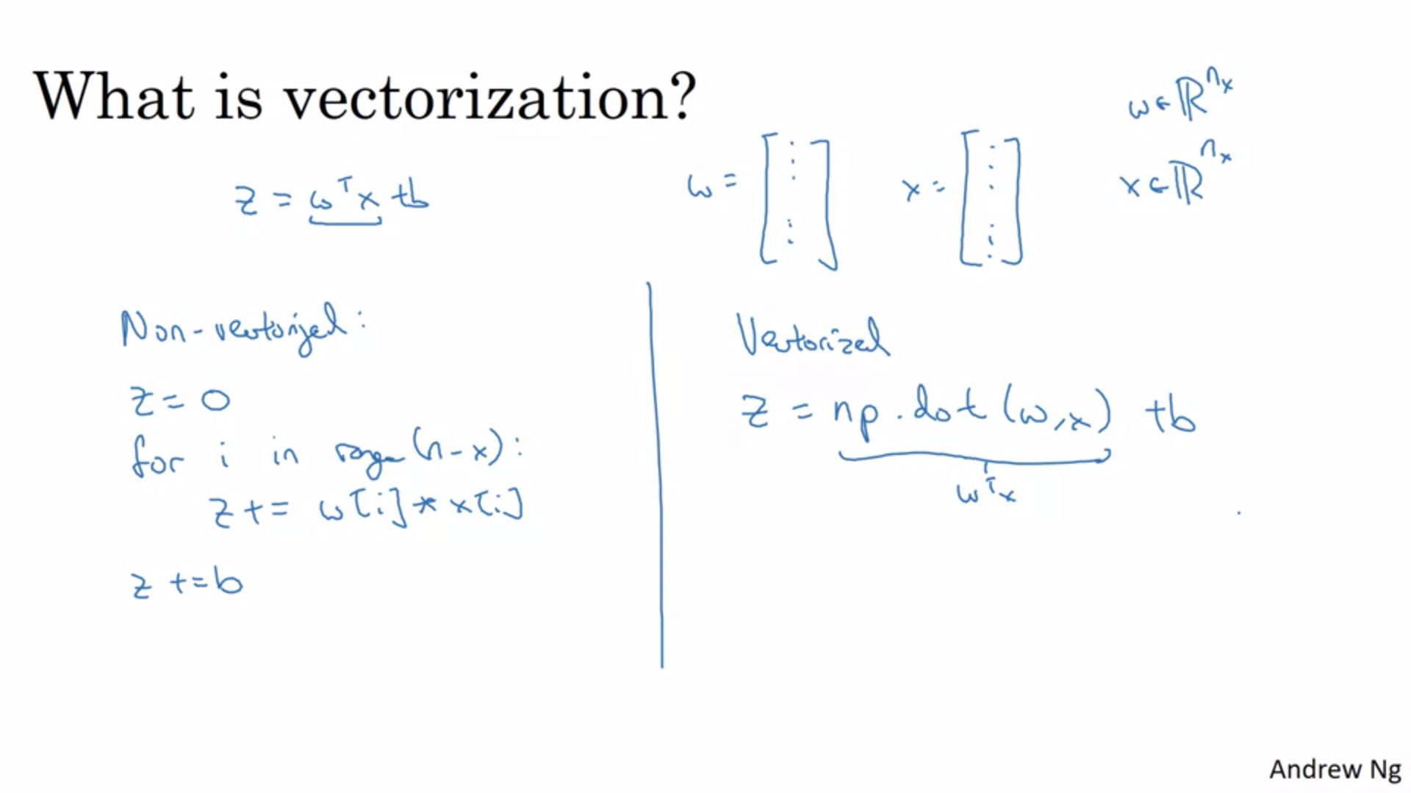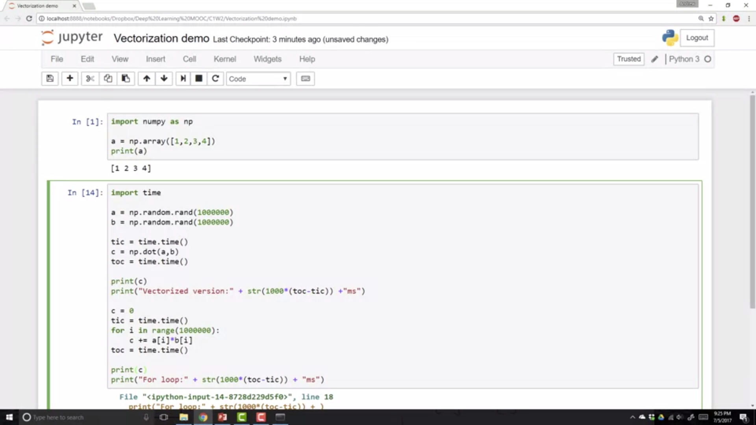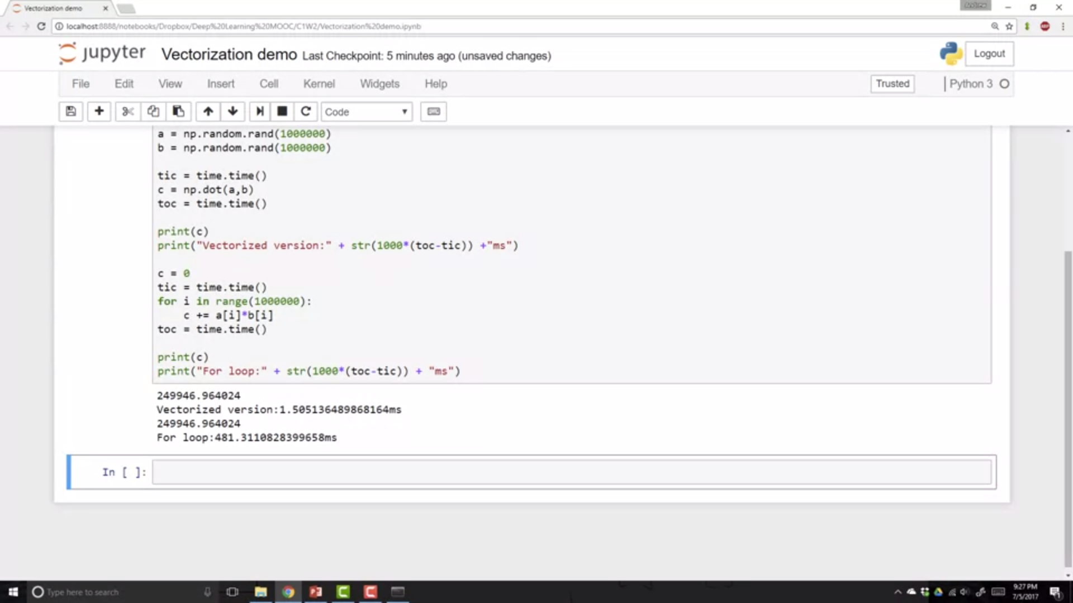

400x slowdown without vectorization

Both GPUs and CPUs have kernel instructions (SIMD – single instruction multiple data). Python numpy will much better be capable of using parallelization with vectorization.

GPUs are remarkably good at SIMD calculations but CPUs are also quite good at them.

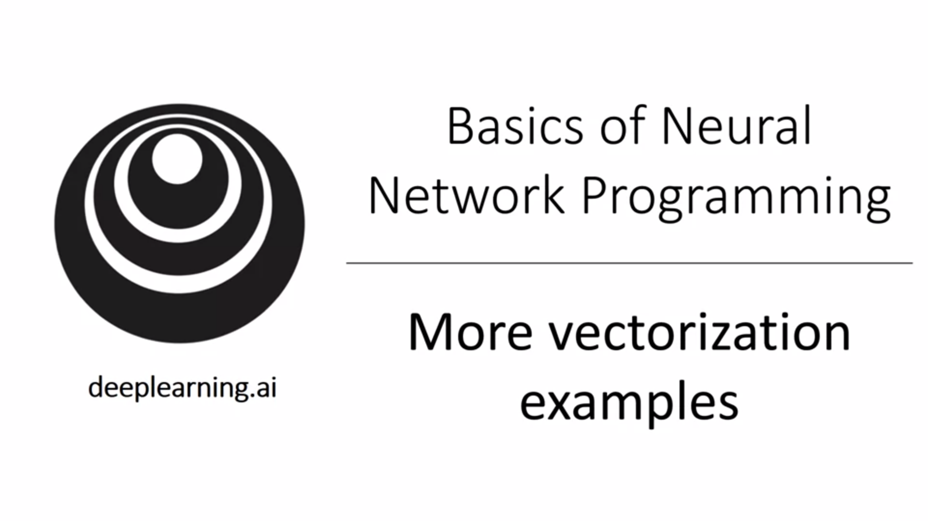

It is not always possible to not use a for loop.

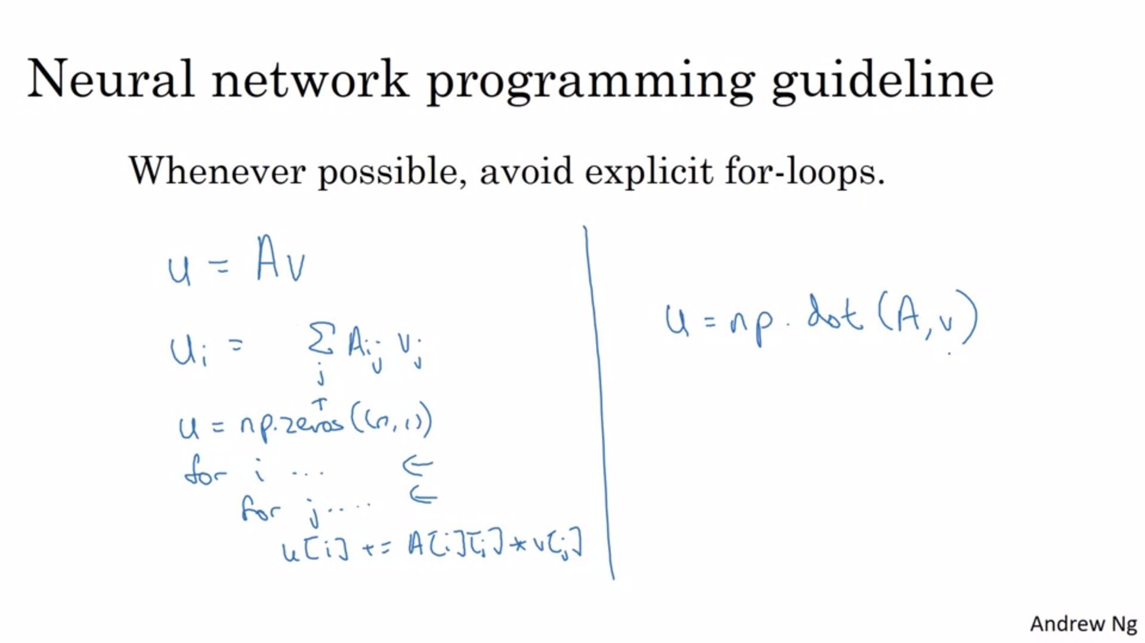

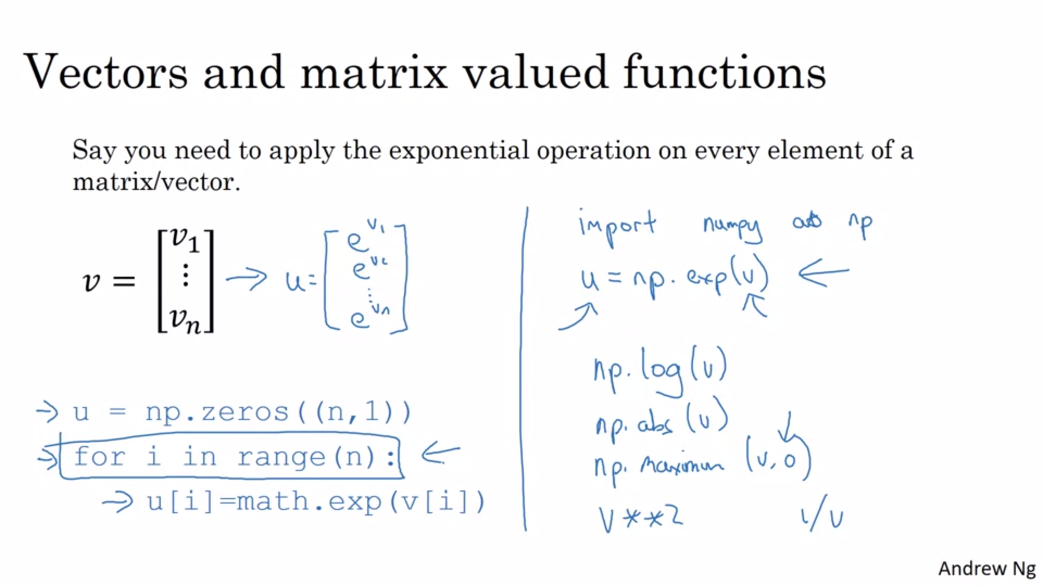

Whenever you are tempted to write a for loop think about build in numpy functions.

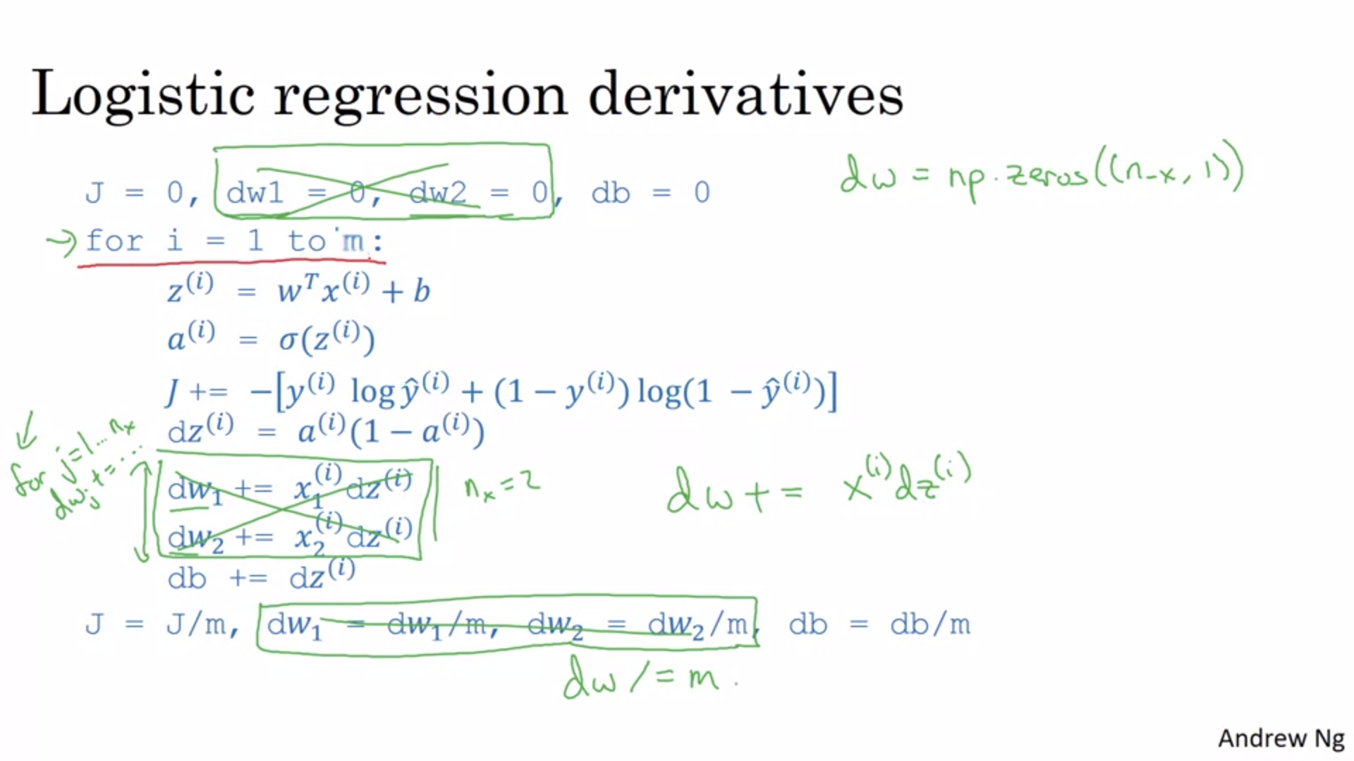

Here we get rid of one for loop (the one looping over the features of x).

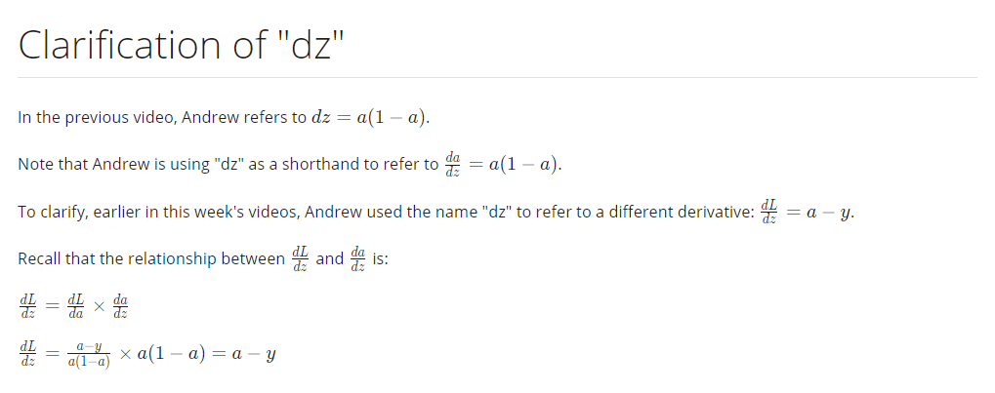

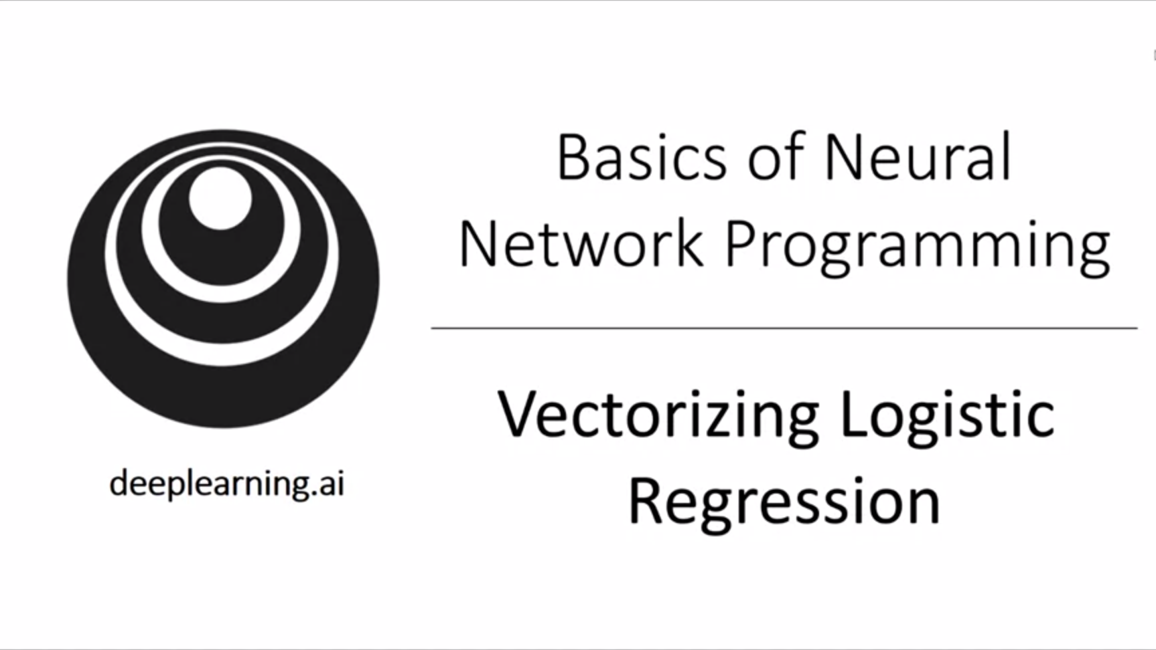

Do one entire step of gradient descent without using any explicit for loop.

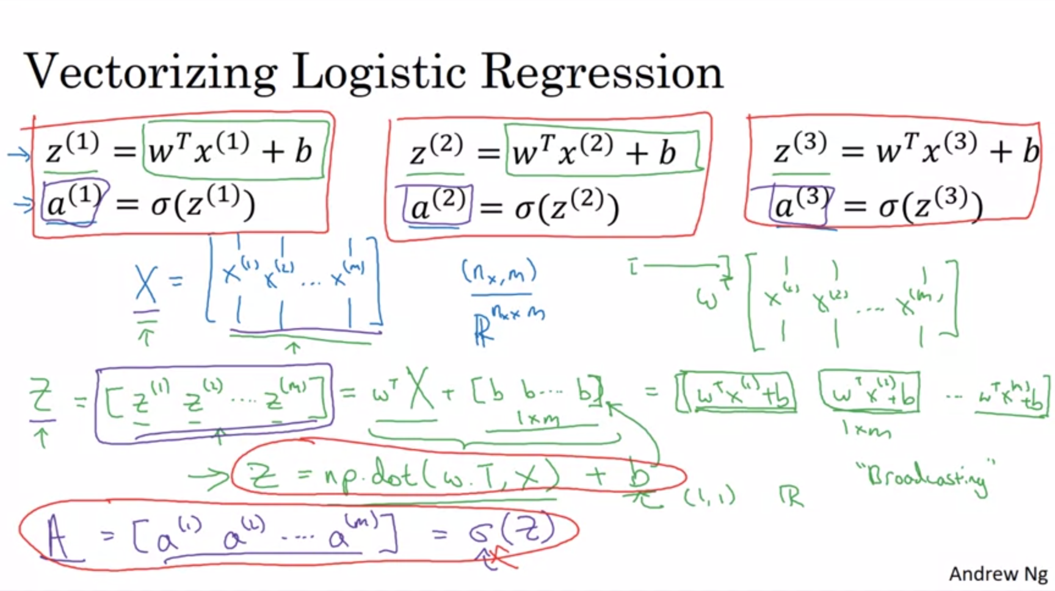

Stack together training inputs as columns.

Broadcasting is used to expand b into row vector.

Vector-valued sigmoid function.

This was forward propagation but vectorization can also be used to efficiently implement backward propagation.

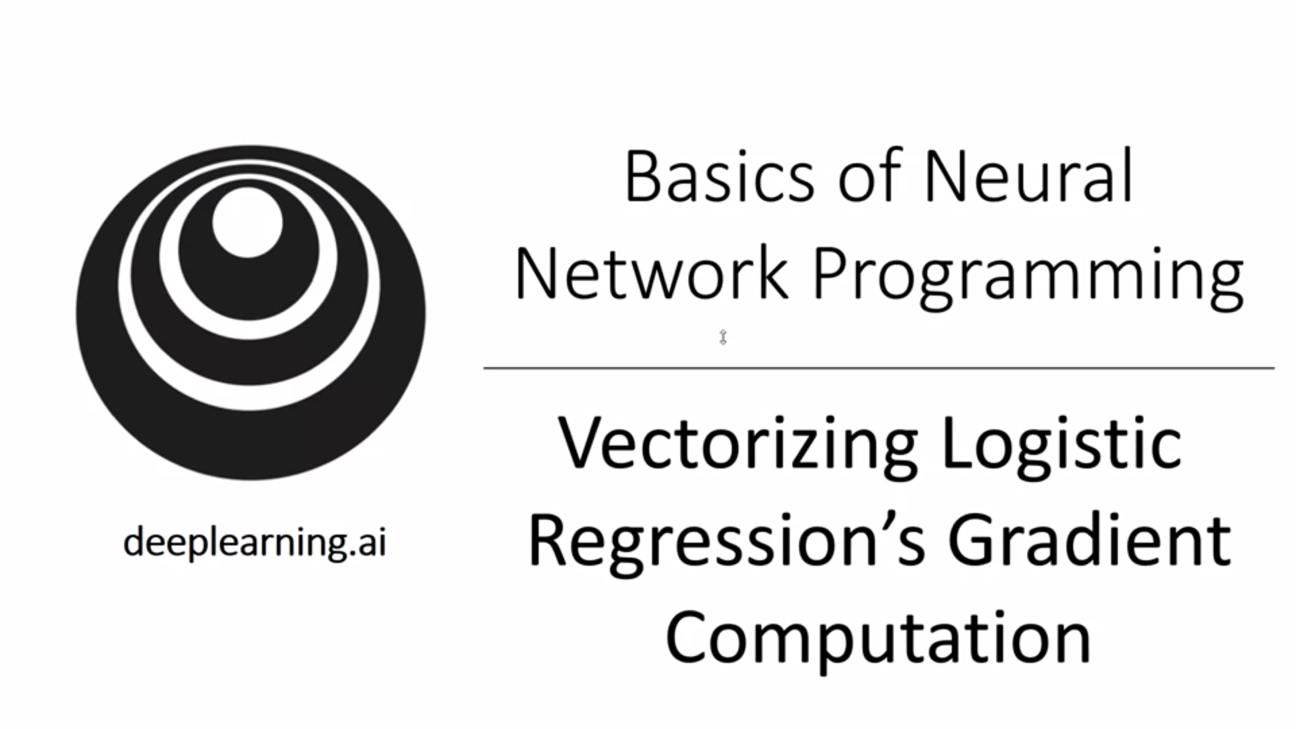

We already got rid of the for loop over the different w’s. Now we also get rid of the for loop to loop over all the training examples.

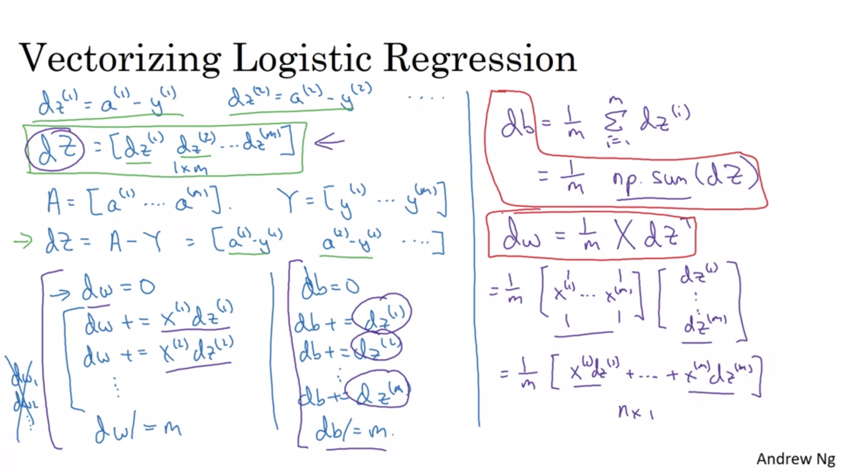

Now let’s put everything together.

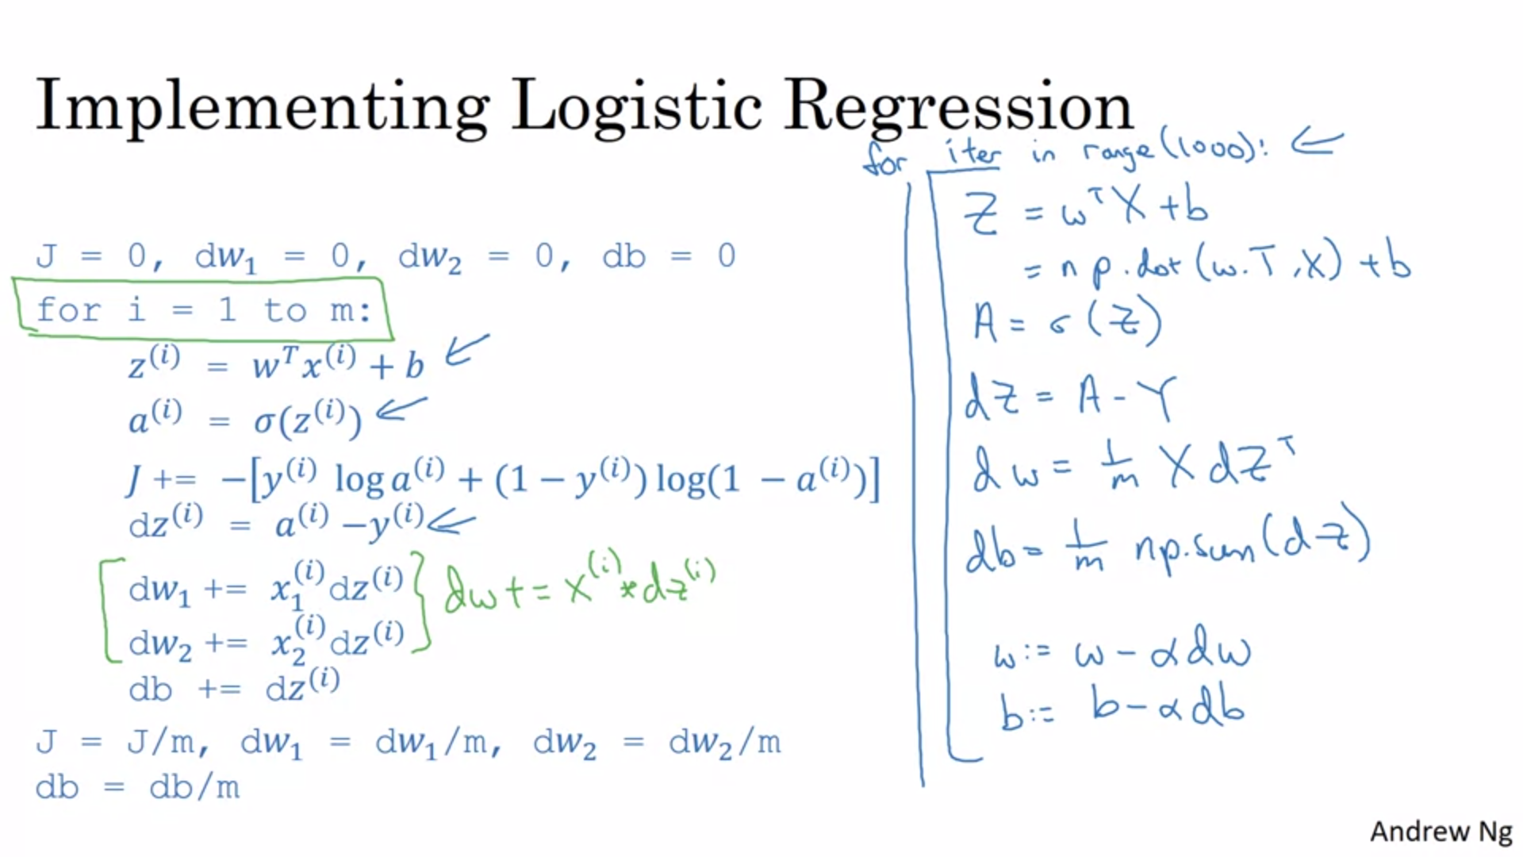

The for loop to do multiple steps of gradient descent is still needed. There is no way to get rid of that one.

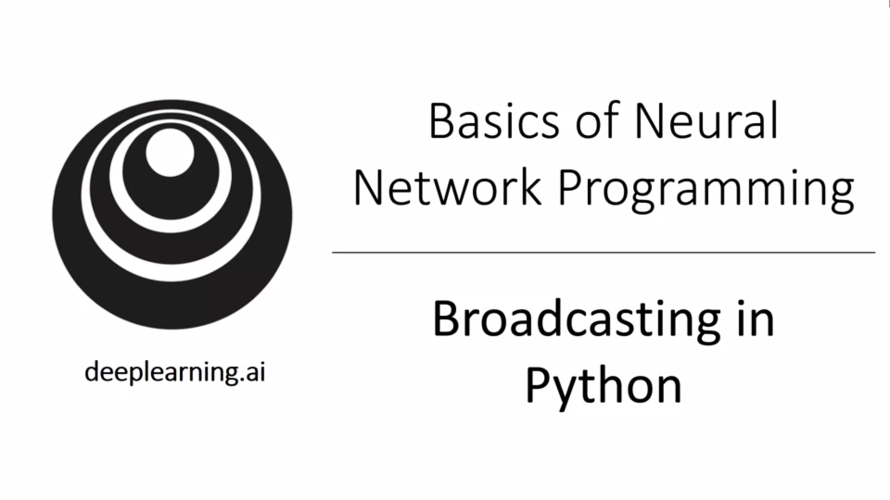

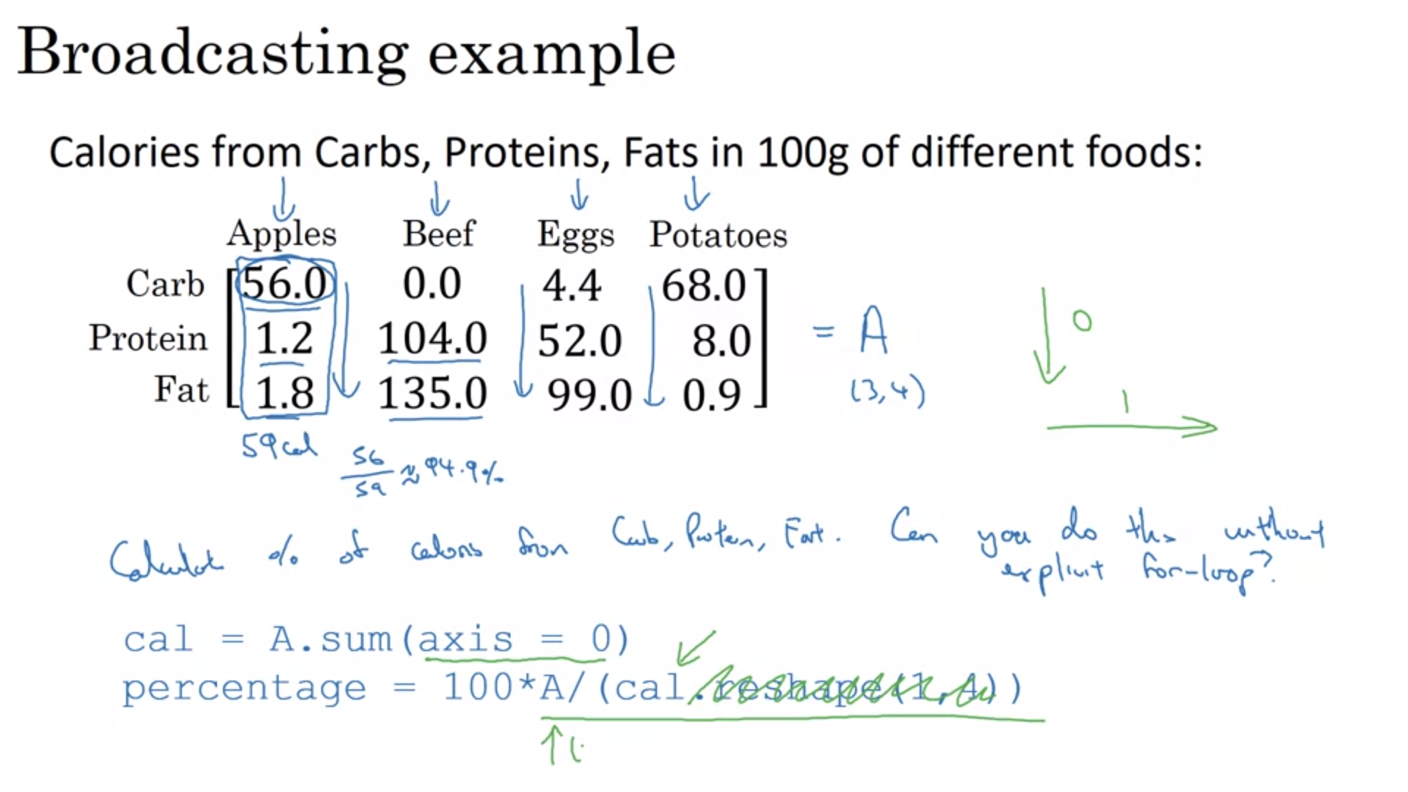

Axis 0 means sum vertically.

This is an example of broadcasting because cal Is only (1,4). Reshape is useful to make sure that shapes are correct. It is a very inexpensive command.

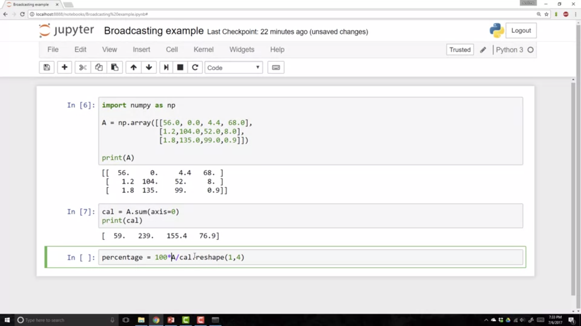

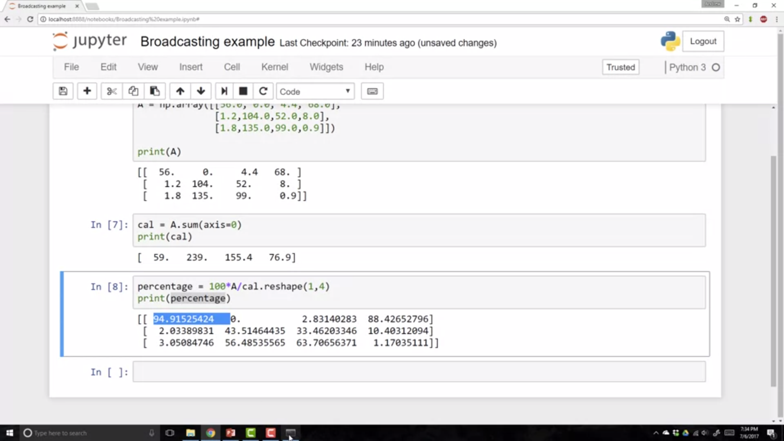

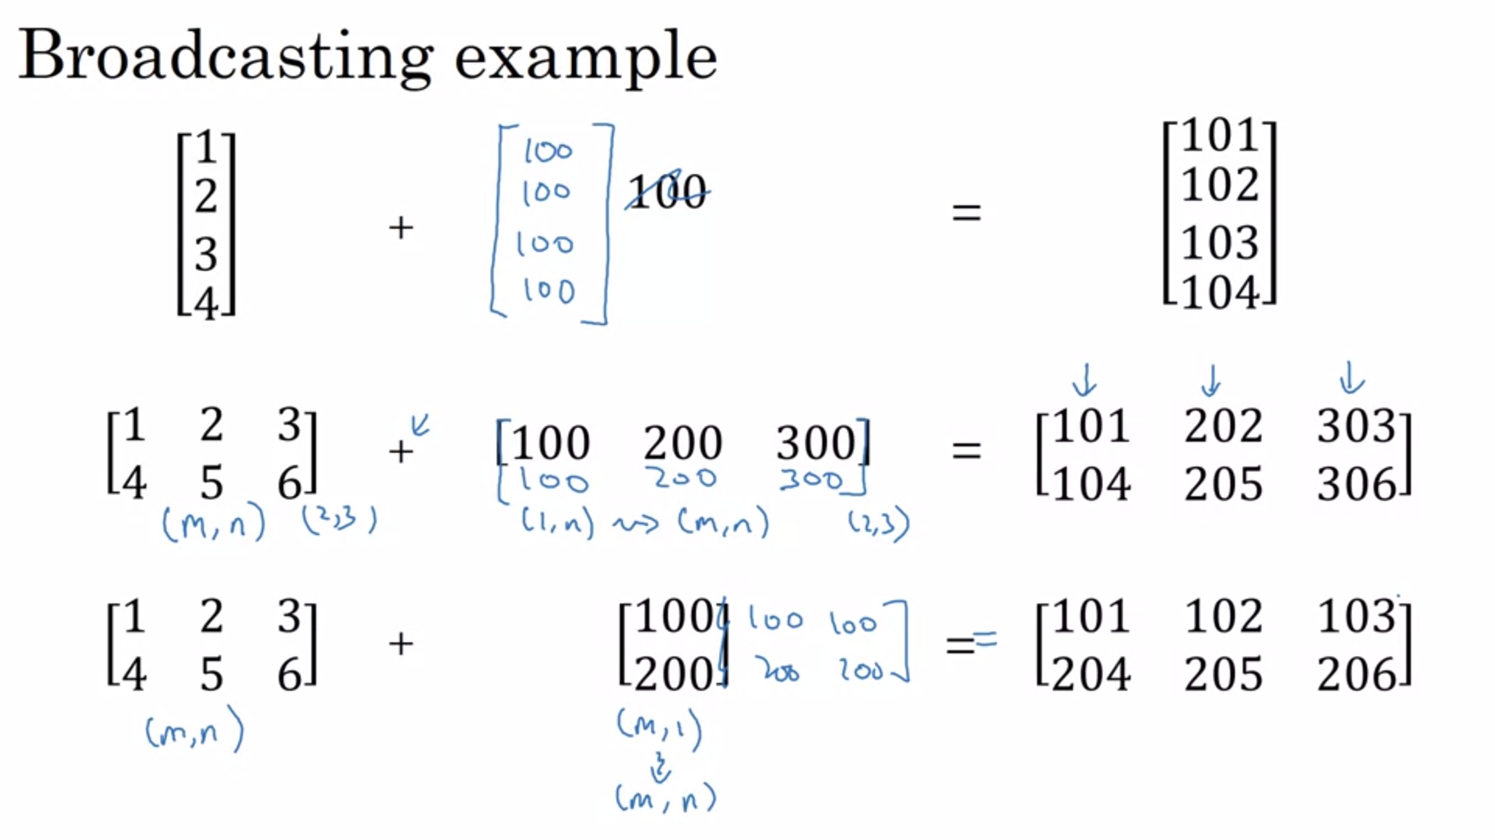

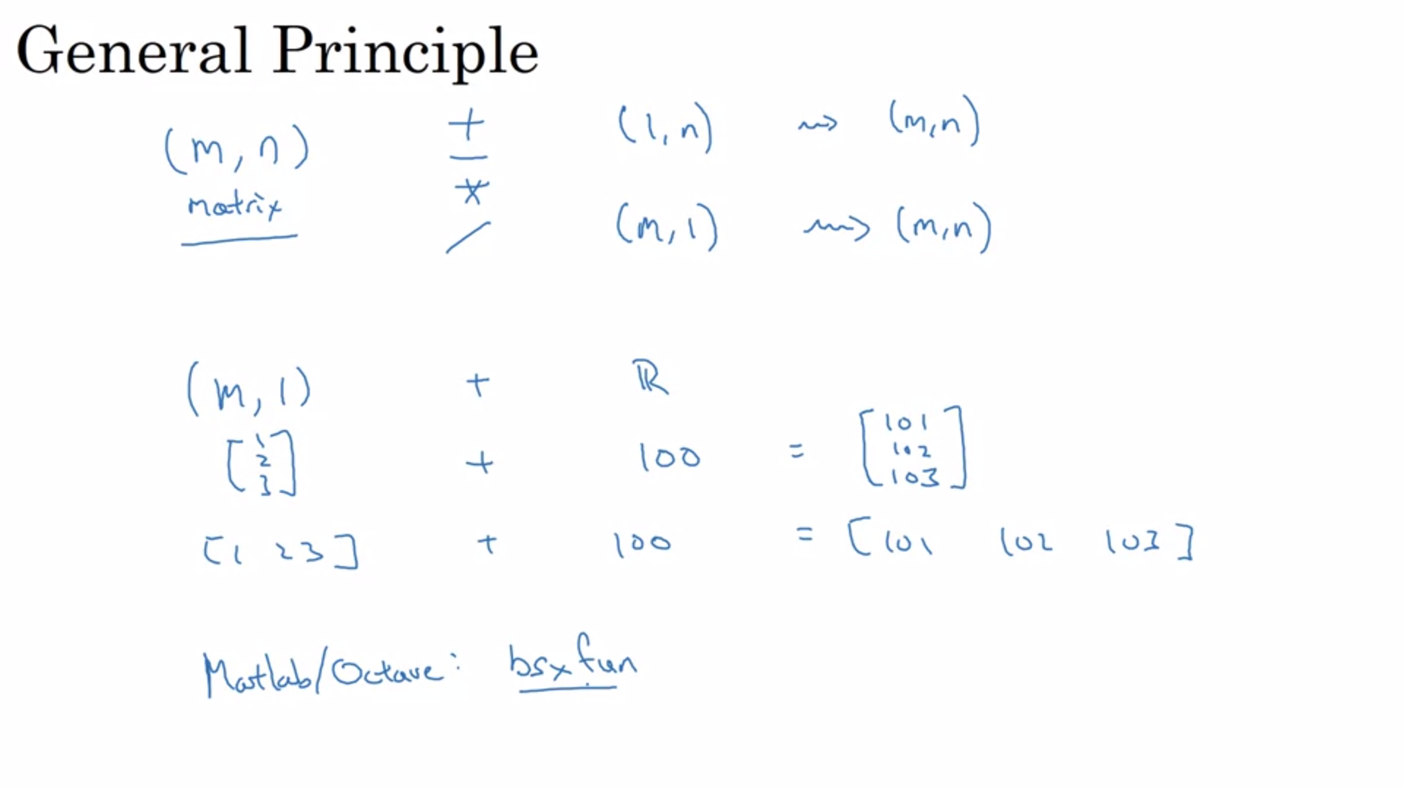

Broadcasting is a very useful trick to make things faster but it is also important to understand to not produce errors.

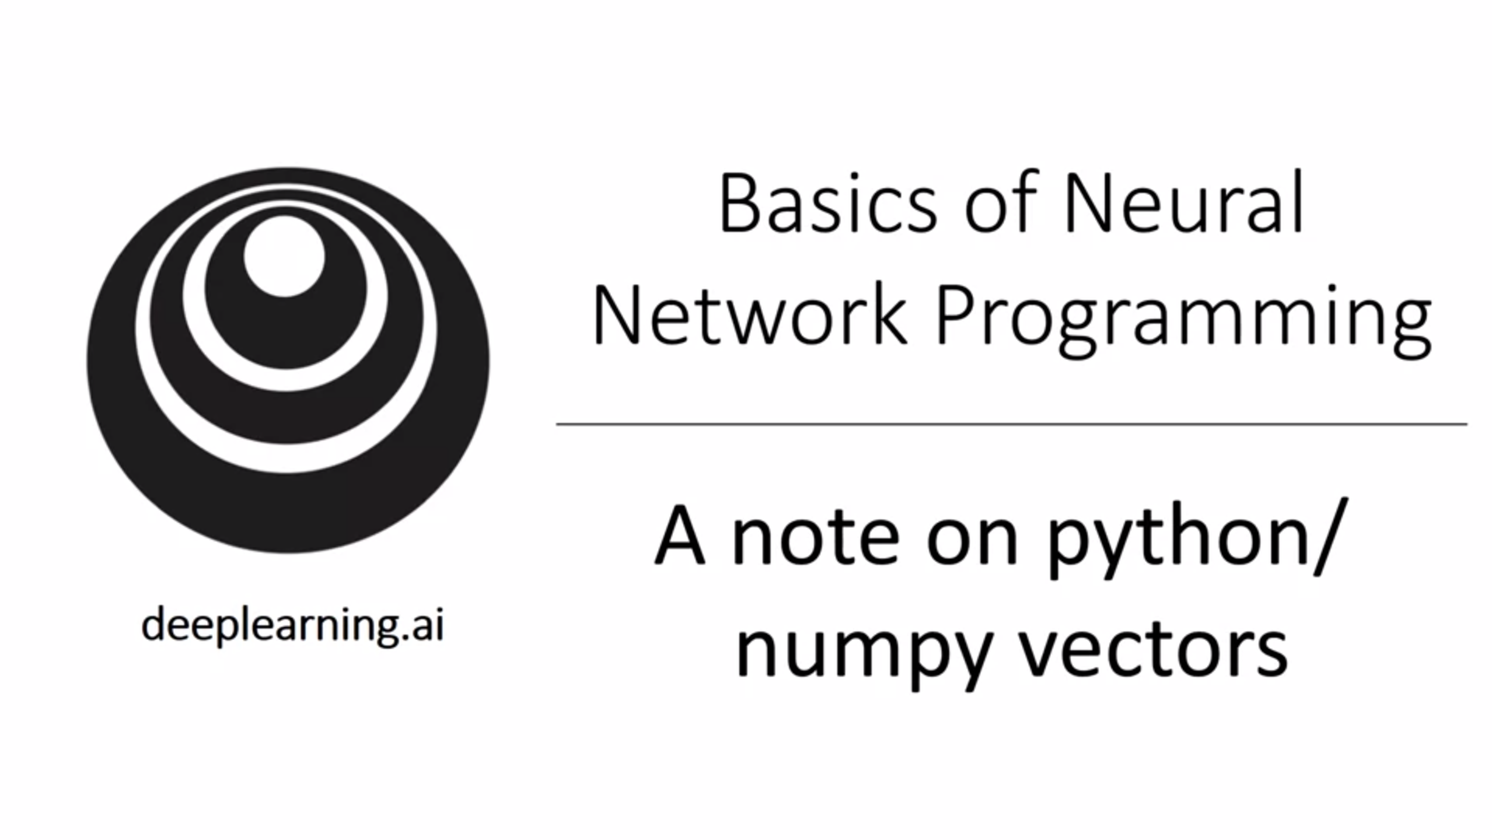

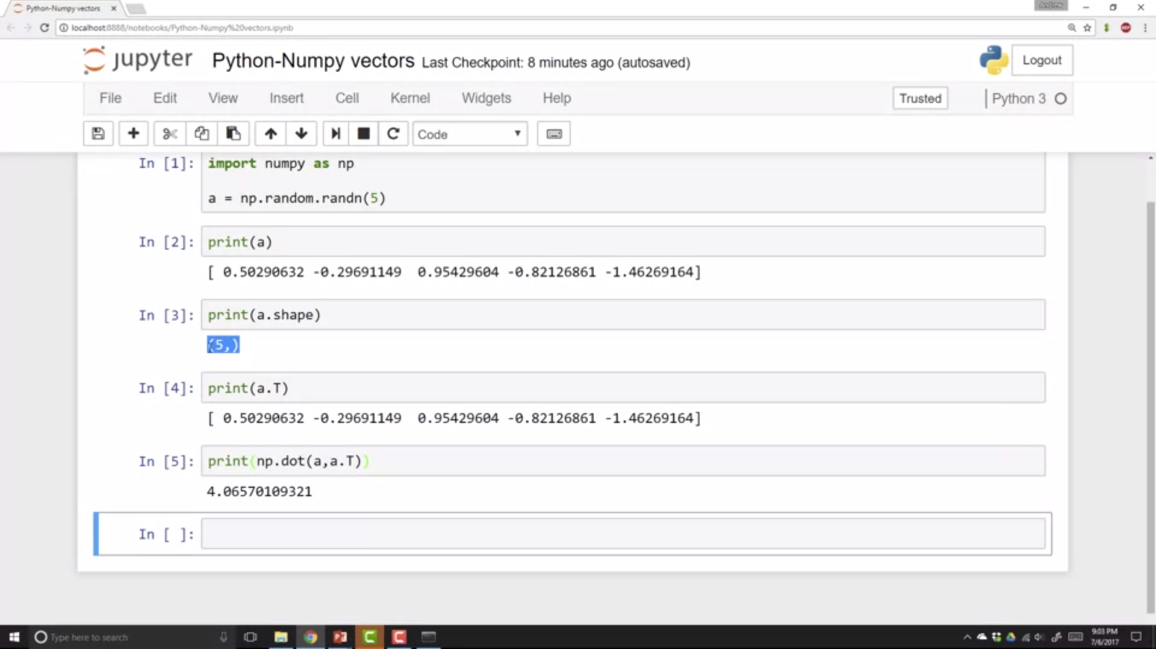

The flexibility of Python is both a strength and a weakness. It can lead to very strange bugs bug it helps you get things done fast. Andre will share some tips and tricks.

Rank-1 arrays have slightly non-intuitive effects. They have shape (x,).

He would recommend not to use rank-1 arrays.

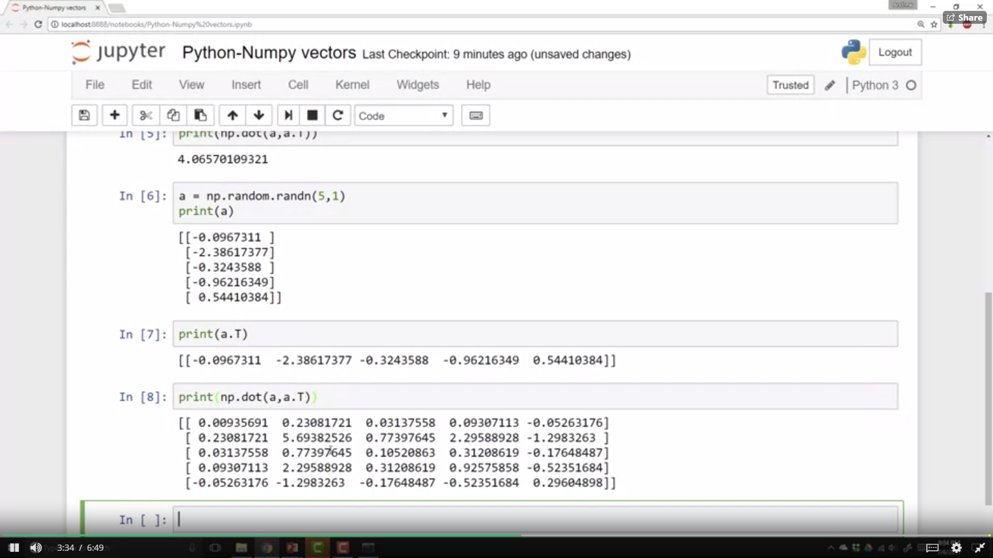

Rank-1 arrays do not behave consistently neither as row nor column vector. Instead commit to make it either a row or column vector.

Use assertion statements to make sure the shape is as expected! Throw them in the code. Reshape can also be used.

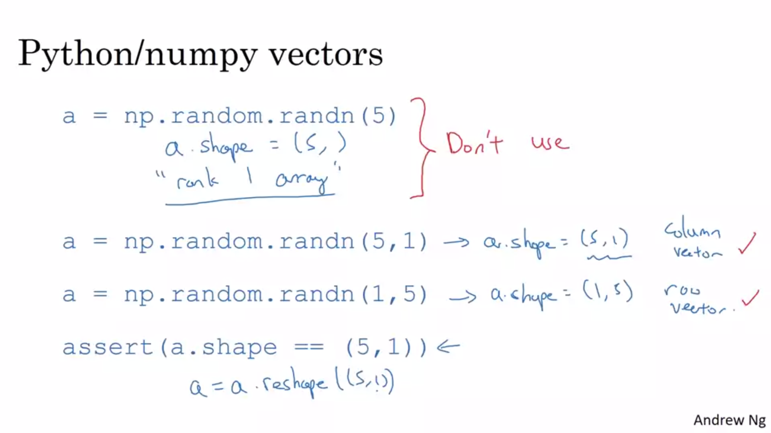

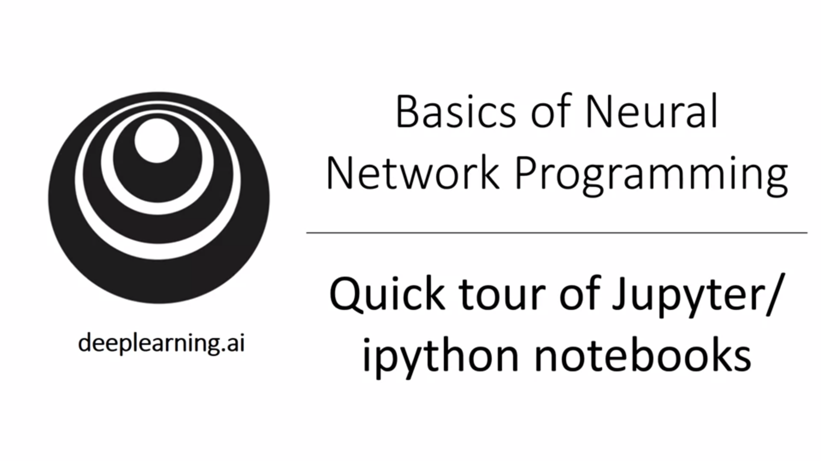 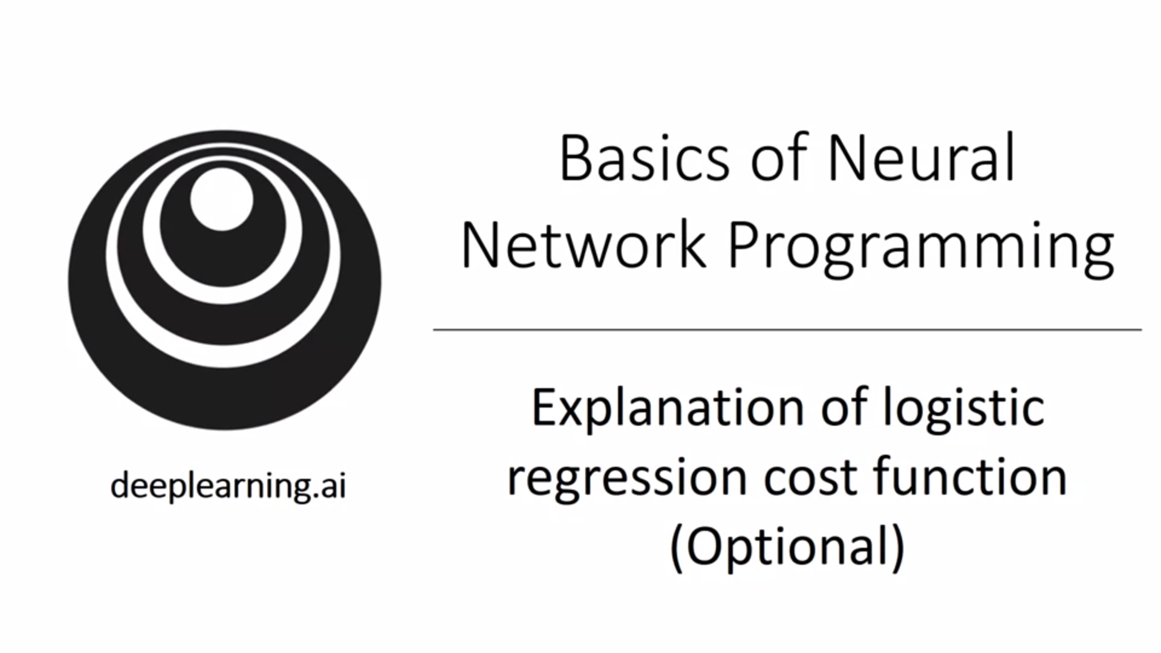

Why do we use the particular cost function that we had for logistic regression?

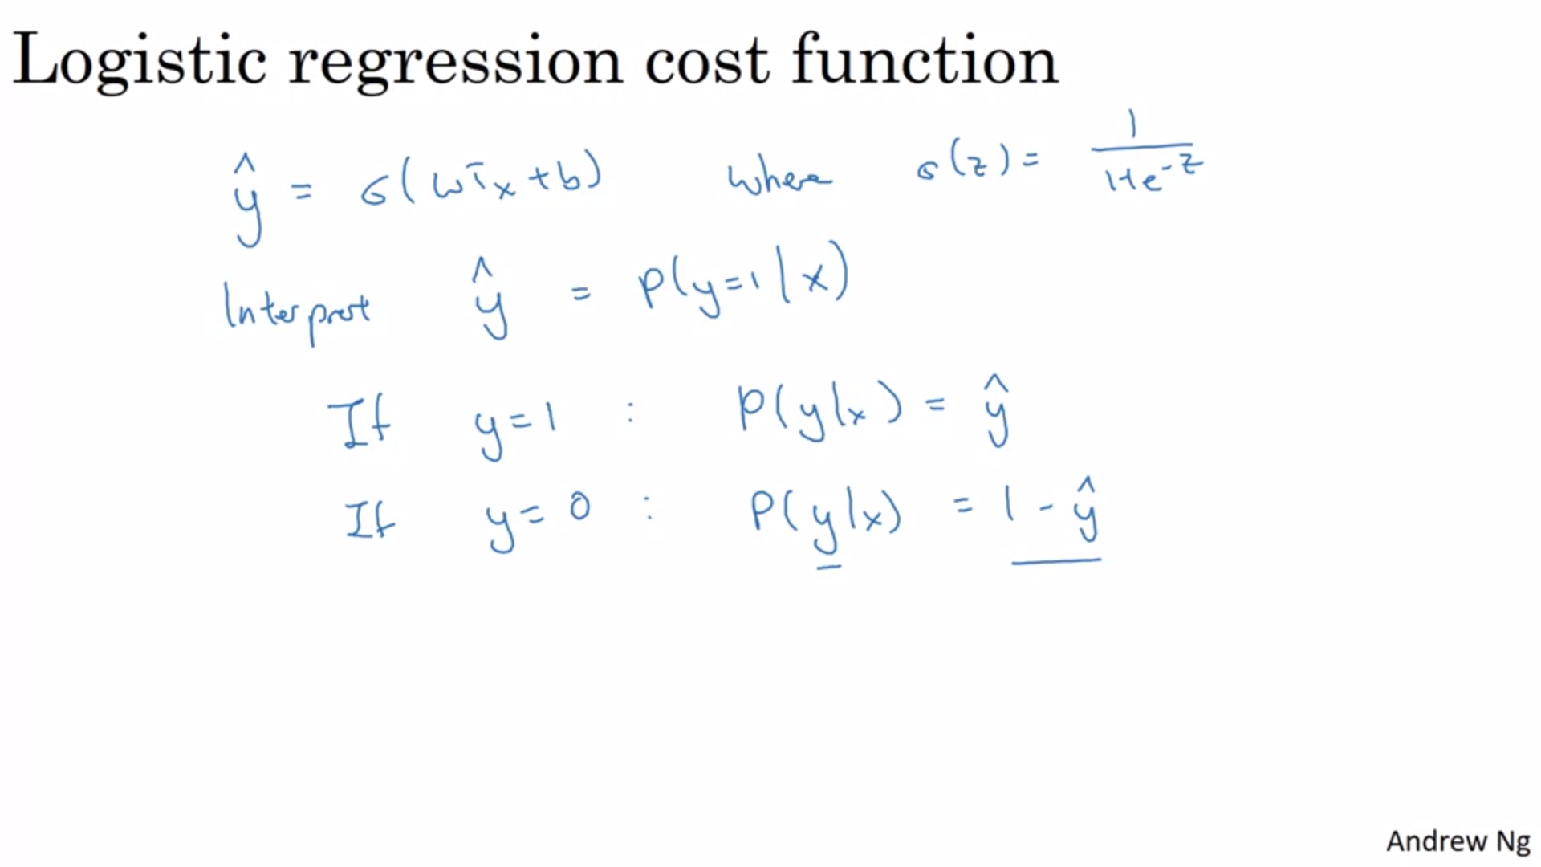

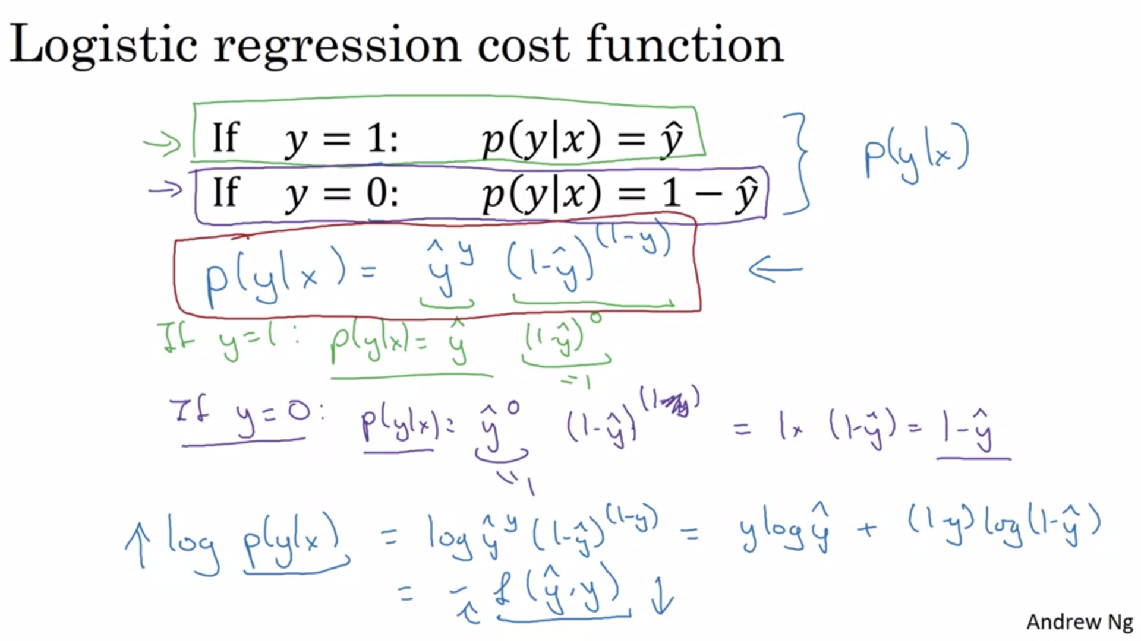

What we have seen is that this equation is a correct definition for p(y|x). The log function is a strictly monotonically increasing function. Maximizing the function with log gives a similar result as without. The negative sign is there because usually we want to make probabilities large. But for the loss function we want to minimize the function.

This is the loss function for an individual example. How about the entire training set?

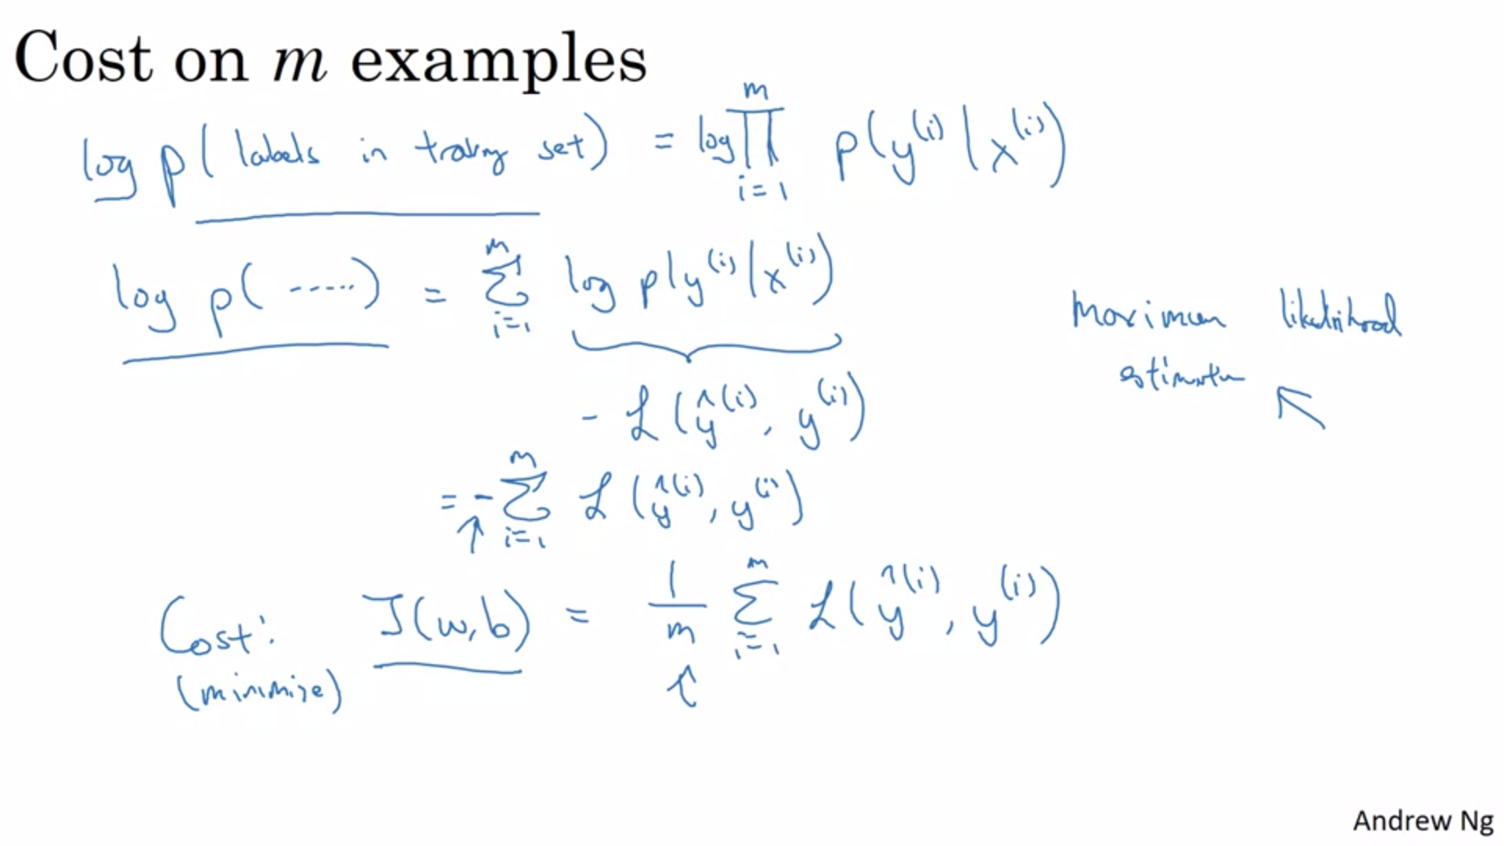

Maximum Likelihood estimation is used to find the parameters that maximize the probability. Maximizing the log is the same as without. This justifies the cost function of the logistic regression. For convenience we add a 1/m extra scaling factor.

The assumption is that our training examples are iid.